Viruses and Bacteria
Fill in Notes
The influenza pandemic of 1918-1919 killed more people than World War I, at somewhere between 20 and 40 million people.
More people died of influenza in a single year than in four-years of the Black Death (1347).
Viruses are pathogens that attack cells from the inside. They hijack your own DNA and use it against you. A virus cannot be treated with antibiotics, it can only run its course until your immune system kicks it out.

Properties of Viruses
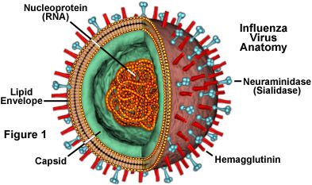
- ________ membranes, cytoplasm, ribosomes, or other cell parts
- cannot move or grow
- can only reproduce inside a host cell
- consist of 2 major parts - a _______________, and hereditary material (DNA or RNA)
- are extremely tiny, only visible with electron microscopes

Virus Structure
Virus has a covering that has a ___________ and sometimes an ______________
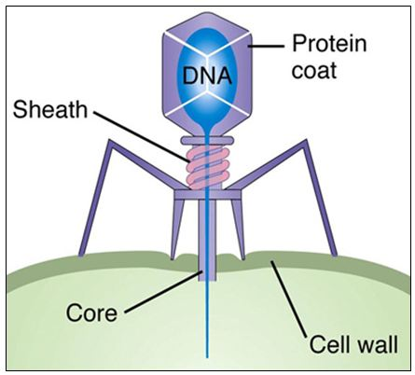
Inner core contains a nucleic acid molecule ________________and various proteins
Viruses are usually very specific to their host and to the cells they can infect.
This is a bacteriophage, a type of virus that attacks bacteria. It is recognizable because it looks like the lunar landing spaceship.

Virus Reproduction

1. Attachment
2. Penetration - the virus is ___________by the cell
(Cell can enter Lysogenic or Lytic Cycle)
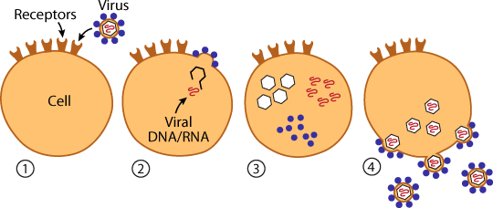
3. Biosynthesis - viral components are made
(protein coat, capsid, DNA/RNA)
4. Maturation - assembly of ____________ components
& Release - viruses leave host cell to infect new cells

Lytic cycle = reproduction occurs, cells ________
Lysogenic cycle = _______________ does not immediately occur (dormancy)
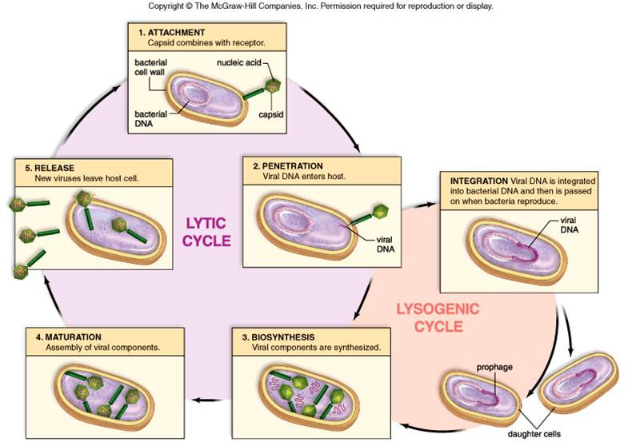
Video

Types of Viruses
Bacteriophages - infect bacteria
Retroviruses - have ______ instead of DNA
Viruses may be named according to
- the associated diseases (poliovirus, rabies)
- the type of disease caused (murine leukemia virus)
- the sites in the body affected or from which the virus was first isolated (rhinovirus, adenovirus)
- where they were first isolated (Ebola virus, Hantavirus),
- the animal that carries the virus (bird flu, swine flu)
- for the way people imagined they were contracted (dengue = ‘evil spirit’; influenza = ‘influence’ of bad air).

Monerans
- Unicellular without a ______________
- Microorganisms:
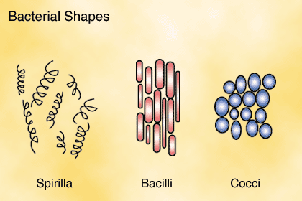
- Structure:
- Reproduce asexually (binary fission) Mitosis
Classified into three types by shape
  - Cocci bacteria - ________________
  - Bacilli bacteria - _____________
  - Spirilla bacteria - ______________
Harmful bacteria cause__________ and food spoilage
- Destroyed by_____________
- Helpful Bacteria are used in environmental ________________, digestion of food, and production of antibiotics(______________________)
and ______________
