Birds and Reptiles – are they related?
- Birds are thought to have evolved from small dinosaurs
- The hunt for the ancestors of living birds began with a specimen of Archaeopteryx, the first known bird, discovered in the early 1860s. Like birds, it had feathers along its arms and tail, but unlike living birds, it also had teeth and a long bony tail. Furthermore, many of the bones in Archaeopteryx's hands, shoulder girdles, pelvis, and feet were distinct, not fused and reduced as they are in living birds. Based on these characteristics, Archaeopteryx was recognized as an intermediate between birds and reptiles; but which reptiles?
- Modern birds descended from a group of two-legged dinosaurs known as theropods, whose members include the towering Tyrannosaurus rex and the smaller velociraptors.
- Bird and reptile worlds are closely linked but scientists disagree on how this looks… an interesting Inquiry project perhaps..

Reptiles
Kingdom Animalia
---Phylum Chordata
------Subphylum Vertebrata
---------Class Reptilia
------------Orders: Sphenodonta, Squamata, Testudines, Crocodilia
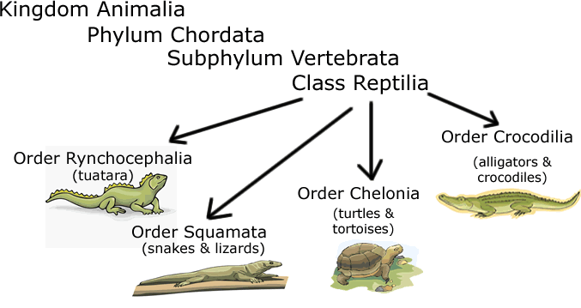
Testudines
Sphenodonta

Characteristics of Reptiles
1. _______________________________________________________
2. Ectothermic (cold-blooded)
3. Dry scaly skin
4. Amniote eggs
5. Respiration with lungs
6. Ventricle partially divided
7. Internal fertilization

The Amniote Egg
Contains a water and food supply for the developing embryo and can be layed on land.
Must be fertilized __________________________, has a shell
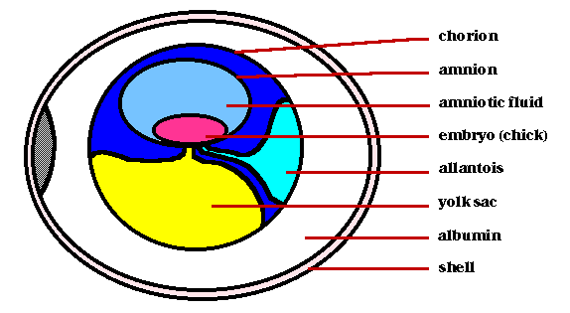
Structure | Function
amnion | provides a watery environment for the embryo
yolk Sac | contains the food for the embryo
allantois | stores waste
chorion | allows oxygen to enter and carbon dioxide to leave
albumin | egg white
_______________ - eggs are laid and incubated outside the body
_________________ - eggs are incubated inside the body, born live
_________________ - live birth, no egg (humans)

Types of Reptiles
4 Main Groups (ORDERS)
Crocodilia = crocodiles, alligators
Testudines = turtles and tortoises
Sphenodonta = tuatara
Squamata = lizards, snakes, worm lizards ( largest group )
1. Order Sphenodonta
- are only found in New Zealand
- have no external ears
- have a _________________
2. Order Testudines
- Tortoises and turtles
- __________________________________________________________________________
- Sea turtles are one of the Earth's most ancient creatures. The seven species that can be found today have been around for 110 million years, since the time of the dinosaurs. They can live up to 50 years or more and have similar life spans to humans. Sea turtles are classified as endangered due mostly to human activity.
- The top of a turtle’s shell is the carapace
- the bottom is the plastron
3. Order Crocodilia
- alligators and crocodiles
- Alligators are found mainly in North and South America and only live in freshwater
- Alligators only show their upper teeth when their mouth is closed, and their snouts are rounder (u-shaped)
- Crocodiles can live _________________________, most are found in Africa, India, and Asia
- Crocs have a pointed snout and show both rows of teeth when their mouths are closed.
- The Nile Crocodile takes care of its young, a unique trait among reptiles
4. Order Squamata
- Snakes and lizards, and worm lizards
- Most diverse group with 7400 living species
- Shed their skin periodically either in _________________________________
- Have jointed jaws that are strong and flexible
- First appeared during the mid Jurassic period (185-165 million years ago)

Birds
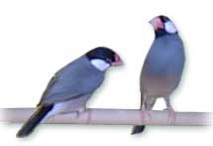

Classification
-Kingdom Animalia
---Phylum Chordata
------Subphylum Vertebrata
---------Class Aves

Characteristics of Birds
- _______________________________________
- Feathers
- Hollow, lightweight bones
- Endothermic
- Efficient respiration
- Heart with a completely divided ventricle (4 chambers)
- Scaley feet (birds are related to reptiles)
- furculum (wishbone)
*Ornithology is the study of birds

Feathers
Types of feathers
____________________ - provide insulation
____________________ - cover head and body, provide coloration
____________________ - on wings and tail, provide lift
Feathers are covered in oil to keep them water proof - "like water off a duck's back" - this oil is secreted from a preen gland
Preening is a behavior that replaces the oil on feathers, and repairs broken links on the vanes

Avian respiration and circulation
A four chambered heart prevents oxygen rich blood from mixing with oxygen poor blood - it is a _____________________
Lungs are connected to _________________, which fill with air during inhalation. The air then is released from the air sacs when the bird exhales - this means that the bird receives oxygen during inhalation and exhalation
The lungs are connected to the _______________________
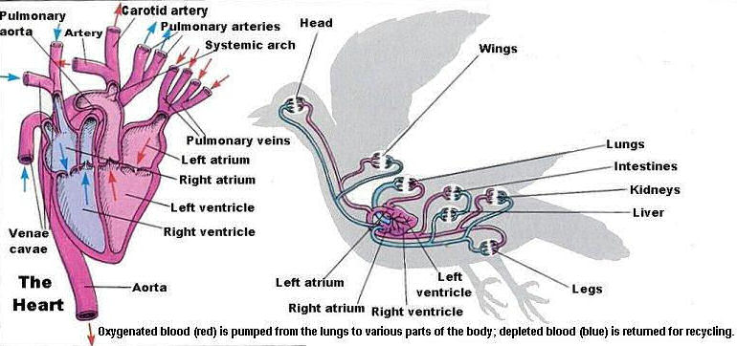

Bird Digestion
Birds digest food quickly, they can't afford the extra weight.
They have no teeth, the breakdown of food occurs in the _________________ - sometimes birds swallow rocks to assist this
The _________________ stores food...mother birds regurgitate food stored in the crop to their babies
Waste exits through the cloaca - and so do eggs
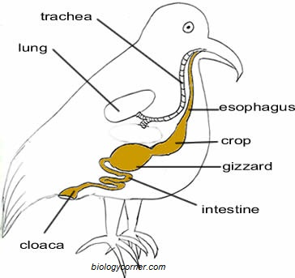

Bird Brain
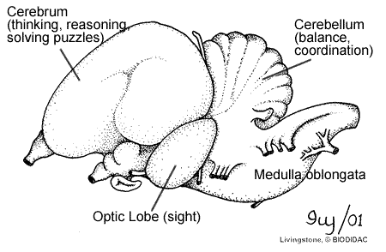
* Birds have an excellent sense of sight, but most do not have a good sense of smell
*Many birds are intelligent and can solve complex puzzles
*Birds can learn to talk, but really they are just mimicking sounds they hear

Beaks and Feet
Adapted to the birds way of life. Study of the beak and the feet of a bird gives information about its lifestyle
Beaks
Short and thick - seed cracking (robin)
Long and thin, slightly curved - eating nectar (hummingbird)
Strong, chisel like - drilling (woodpecker)
Sharp, curved and pointed - tearing flesh (hawk)
Long and flattened - straining algae and plants (ducks)
Spear shaped - spearing fish (heron)
Feet
3 toes in front, 1 behind - perching (robin)
2 toes in front, 2 behind - climbing (parrot)
Powerful curved talons - grasping prey (hawk)
Webbed - swimming (duck)
Long and thin - wading (heron)
Thick and stout - running (ostrich)

Bird Classification
Birds are classified by the beaks and their feet. There are many bird orders, but here are some of the more common orders.
Order Passeriformes - songbirds (bluebirds, robins, sparrow)
Order Falconiformes - birds of prey (hawk, falcon, eagle)
Order Anseriformes - swimming birds (duck, goose, swan)
Order Galliformes - fowl (pheasant, turkey)
Order Ciconiformes - wading birds (heron, flamingo)
*You will not need to know the orders, but you should know how the birds are grouped. For example, a hawk is more closely related to a falcon than it is to a bluebird.

Courtship Behavior and Reproduction
Birds often engage in _______________________ behavior for mating purposes. These include:
Building nests
Dancing and posturing
Bringing gifts
Bright colorful displays
Singing
Some birds ______________________, and often both parents raise young.
Two types of reproduction occur in birds:
Some birds incubate eggs for a long time - chicks are born with feathers and can walk/swim (ducks)
Some birds incubate eggs a short time - chicks are born featherless and helpless (robins)

Myths about Birds
Birds do not normally have a good sense of smell, except in carrion eaters (vultures) - a baby bird that falls out of a nest can be put back in, the mother probably won't know the difference
Bird poop you find on your car is actually a mixture of urine and solid waste - birds cannot store waste
Some birds can learn to mimic speech, like a parrot - but they can't actually communicate
Eggs bought at the supermarket are not fertilized, you cannot incubate them to hatch a chick.
The term "birdbrain" often describes someone who is stupid - in actuality, some birds are extremely intelligent and can be trained to do tricks and can solve puzzles.
The term "eats like a bird" describes someone who doesn't eat much - in actuality, birds consume a large amount of food to maintain a high metabolism (endothermic)

Some special terms to describe birds in groups.
A murder of crows
A gaggle of geese
A herd of swans
A cast of hawks
A brood of chickens
A murmuration of starlings
A watch of nightingales
A host of sparrows
A bevy of quails

