Protists
Protists belong to the Kingdom Protista, which include mostly unicellular organisms that do not fit into the other kingdoms.

Characteristics of Protists
- mostly ______________________, some are multicellular (algae)
- can be heterotrophic or autotrophic
- most live in water (though some live in moist soil or even the human body)
- ALL are _________________________ (have a nucleus)
- A protist is any organism that is not a plant, animal or fungus
- Protista = the very first

Classification of Protists
- how they obtain nutrition
- how they move

Animallike Protists – also called ___________ (means “first animal”) – heterotrophs
Plantlike Protists – also called algae – autotrophs
Funguslike Protists – heterotrophs, decomposers, external digestion

Four Phyla of Animal-like Protists
– Classified by how they move

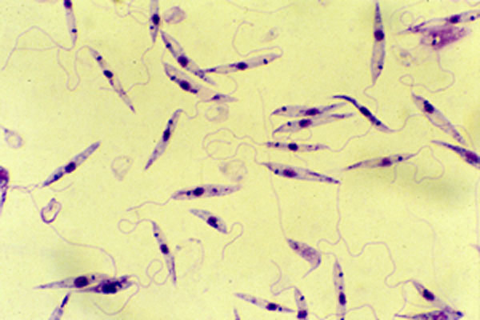
- Zooflagellates – _________
- Sarcodines – extensions of cytoplasm (pseudopodia)
- Ciliates – _____________
- Sporozoans – do not move

Zooflagellates
- move using one or two ___________
- absorb food across membrane
- Ex. Leishmania

Sarcodines
- moves using pseudopodia ( “false feet” ), which are like extensions of the cytoplasm —_________________
- ingests food by surrounding and engulfing food (endocytosis), creating a ______________
- reproducing by binary fission (mitosis)
- contractile vacuole – removes excess water
- can cause amebic dysentery in humans – diarrhea and stomach upset from drinking contaminated water
- Other sarcodines: Foraminferans, Heliozoans
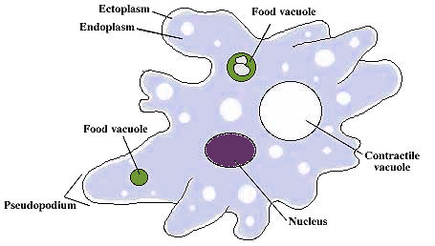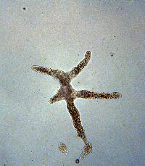
Video: Ameba Proteus

Ciliates
- Paramecium (See Paramecium Coloring Sheet)
- move using cilia
- has two nuclei: macronucleus, micronucleus
- food is gathered through the :mouth pore, moved into a____________, forms a food vacuole
- __________________ is used for removing waste
- __________________________ removes excess water
- exhibits avoidance behavior
- reproduces asexually (binary fission) or sexually (conjugation)
- outer membrane -pellicle- is rigid and paramecia are always the same shape, like a shoe
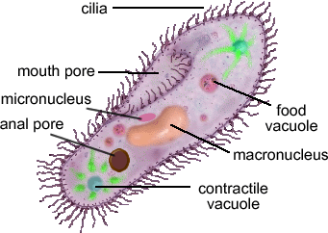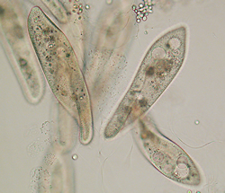

Sporozoans
- do not move on their own
- ________________________
- Malaria is caused by a sporozoan (Plasmodium), which infects the liver and blood; transmitted by mosquitos

Plantlike Protists: Unicellular Algae
- contain chlorophyll and carry out _________________________
- commonly called algae
- four phyla: euglenophytes, chrysophytes, diatoms, dinoflagellates
- accessory pigments help absorb light, give algae a variety of colors

Euglenophytes
- live in water
- have _________________ for movement
- use chloroplasts for photosynthesis, but can turn into heterotrophs if they are kept in the dark
- ___________________ used for sensing light and dark
- pellicle - like a cell wall, helps maintain their shapes
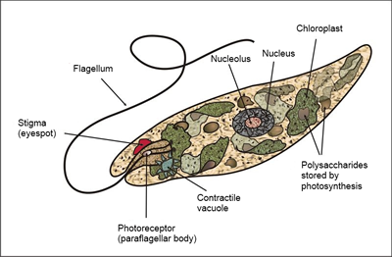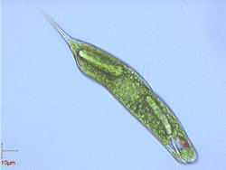
Chrysophytes  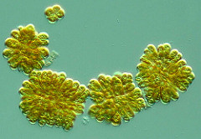 | Diatoms  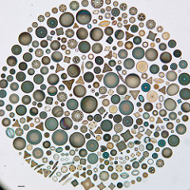 | Dinoflagellates  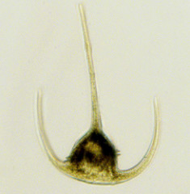

Ecology of Unicellular Algae

Plantlike Protists: Red, Brown, Green Algae
- make up the base of aquatic food chains
- ________________________ makes up half of the photosynthesis that occurs on earth (oxygen)
- can cause Red Tides - algal blooms - which are toxic
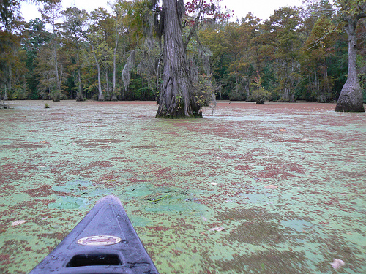
Green Algae: Phylum Chlorophyta
Unicellular green algae, Colonial (volvox), Multicellular (ulva, sea lettuce)
Spirogyra
- live in water, multicellular
- named after a spiral shaped chloroplast
- autotrophic
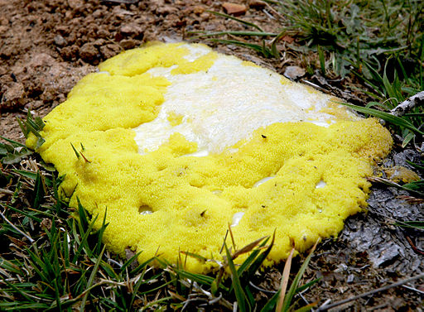
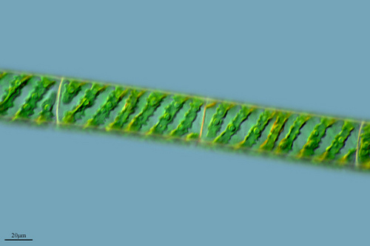

Funguslike Protists
- heterotrophs, __________________
- called slime molds and water molds
- water molds responsible for the Irish Great Potato Famine

Dog Vomit Slime Mold - because it looks like dog puke, but it's really a protist, in the phylum Myxomycota

