Protista Crossword

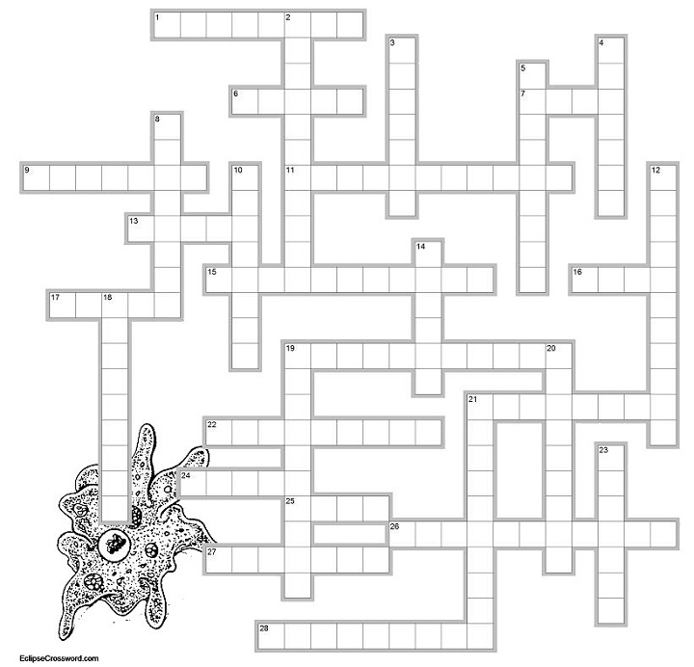

Down
2. removes excess water in ameba and paramecium; ____ vacuole
3. control center of the cell
4. in euglena, used to detect light
5. has a spiral shaped chloroplast
8. Kingdom that includes ameba and paramecium
10. tail-like structure that functions in movement
12. organism that has only one cell
14. a colonial algae
18. any organism that has a nucleus
19. protist that is shaped like a shoe and uses cilia to move
20. organism that can make its own food
21. the name of the protist that causes malaria
23. disease carried by mosquitoes
Across
1. stiff outer membrane of euglena and paramecium
6. where ameba and paramecium live
7. indentation in paramecium whree food is taken in; mouth ___
9. type of asexual reproduction, binary _____
11. sexual reproduction in paremecium
13. structures that help paramecium move
15. an organism that must consume food
16. Protozoan are classified by how they _____
17. the name of this protist means "change"
19. name means "false foot"
21. name means "first animal"
22. can be caused by amebas in drinking water
24. autotrophic, plant-like protists
25. formed by ameba during unfavorable conditions
26. organelle that carries out photosynthesis
27. where food is digested; food _______
28. cytoplasm located in the interior of the cell

