Paramecium Coloring
Paramecium are unicellular protozoans classified in the phylum Ciliophora (pronounced sill-ee-uh-FORE-uh), and the Kingdom Protista. They live in quiet or stagnant ponds and are an essential part of the food chain. They feed on algae and other microorganisms, and other small organisms eat them. All members of the Phylum Ciliophora move by tiny hair-like projections called cilia. Color all cilia black.The paramecium cannot change its shape like the ameba because it has a thick outer membrane called the pellicle. The pellicle surrounds the cell membrane. Color the pellicle light blue.
There are two types of nuclei (plural of nucleus). The large nucleus is called the macronucleus which controls cell activities such as respiration, protein synthesis and digestion. Color the macronucleus red. The much smaller micronucleus is used only during reproduction, color the micronucleus pink. Reproduction in paramecium involves the exchanging of DNA within the micronucleus. In order to do this, two paramecium lie side by side and join at the mouth pore. This process is called conjugation and is a method of sexual reproduction in other microorganisms.
Contractile vacuoles are used in animal cells to remove the excess water. The contractile vacuole is shaped like a star - color the contractile vacuole dark green.
Paramecium are heterotrophs, meaning they must consume food for their energy. Food enters the paramecium through the mouth pore (color orange)and goes to the gullet (color dark blue). The area of the paramecium appears pinched inward and is called the oral groove, cilia sweep food into this area. At the end of the gullet, food vacuoles are formed. Food vacuoles then remain in the cytoplasm until the food is digested. Color all food vacuoles light brown. Undigested food particles are eliminated through the anal pore (color dark brown).
Paramecium can respond to temperature, food, oxygen and toxins and have a very simple defense mechanism. Just inside the pellicle are threadlike organelles called trichocysts. The paramecium can shoot tiny threads out of the cell to entangle a predator or to make themselves appear bigger. Color the trichocysts purple. Paramecium are also known to exhibit avoidance behavior. This is where the paramecium will move away from a negative or unpleasant stimulus.
There are 2 kinds of cytoplasm in the paramecium. The cytoplasm around the edges is clear and is called ectoplasm. Leave the ectoplasm clear. The rest of the cytoplasm is more more dense and appears darker. This is called the endoplasm. Remember that the word "ecto" means outside, and the word "endo" means inside. Color the endoplasm yellow.

Questions:
1. Is the paramecium a unicellular or multicellular organism?

2. To what Phylum and Kingdom do paramecium belong?

3. Define heterotroph.

4. What do paramecium eat?

5. How do all members of the Phylum Ciliophora move?

6. Why can't the paramecium change shape like the ameba?

7. What do the macronucleus and micronucleus do?

8. Define conjugation.

9. What is the function of the contractile vacuole?

10. What is the oral groove?

11. Wastes exit the paramecium through what structure?

12. What is the function of the trichocysts?

13. Compare the endoplasm to the ectoplasm.

14. Define avoidance behavior.

15. Where do paramecium live?
KEY
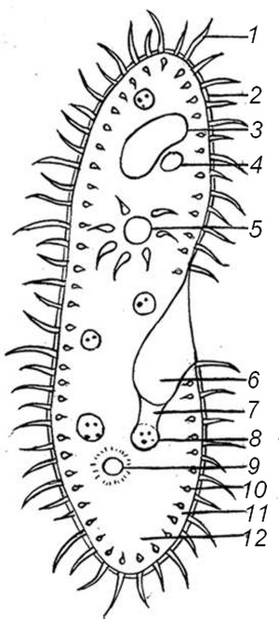
1. Cilia 2. Pellicle 3. Macronucleus
4. Micronucleus 5. Contractile Vacuole
6. Mouth Pore 7. Gullet 8. Food Vacuole
9. Anal Pore 10. Trichocysts
11. Ectoplasm 12. Endoplasm

