Mollusks and Annelids Crossword
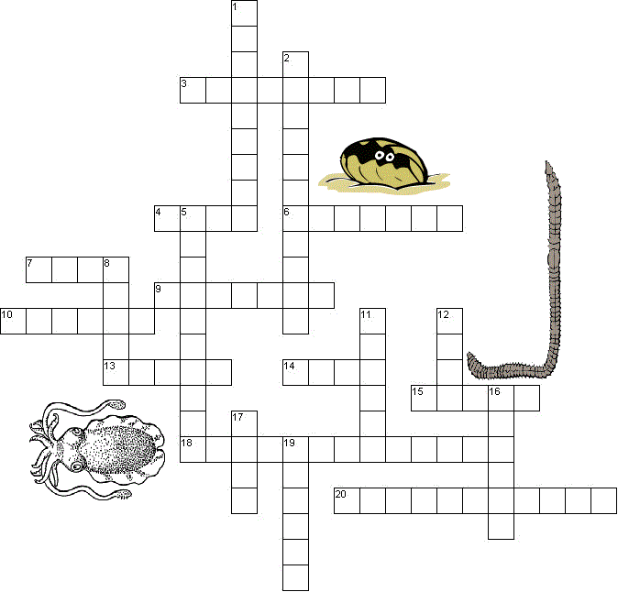

Down
1. a squid uses these to capture prey
2. larval stage of mollusks and annelids
5. a colorful sea dwelling gastropod
8. organs used for respiration in the squid
11. a type of bivalve, makes pearls
12. the color of a poisonous octopus
16. body cavity
17. organ that stores food in the earthworm
19. the heart of the earthworm has five of these
Across
3. used for propulsion in squid (2 words)
4. opening where wastes exit
6. organ used to suck up dirt by worms
7. similar to a snail, but without a shell
9. organ that grinds food in the earthworm
10. the covering of the body of mollusks
13. bristles on the ventral surface of worms
14. 8 of these are found on an octopus
15. related to earthworms, used in "bloodletting"
18. has both male and female sex organs
20. class that contains octopus and squid

