Name: _____________________________________________

Comparing Mollusks Chart
Using what you know about the three major classes of mollusks, complete the chart below by checking the correct column or columns for each characteristic.

Characteristic | Type of Mollusk
 | Gastropods | Bivalves | Cephalopods
1. Intelligent, well developed nervous system
2. Has no distinct head
3. Has an open circulatory system
4. External shells present in some species
5. Bite prey with beak
6. Uses gills for both respiration and food collection
7. All species are carnivorous predators
8. Uses a radula for feeding
9. Can change color for camouflage
10. Can form pearls
11. Use a type of jet propulsion for movement
12. Has bilateral symmetry
13. Has a two part hinged shell
14. Is an invertebrate
15. Some species are venomous

Types of Mollusks Wordsearch
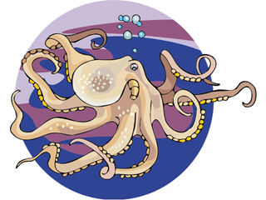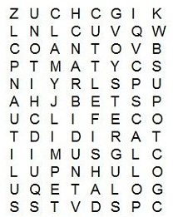
OCTOPUS | CLAM | SLUG | SQUID | OYSTER
NAUTILUS | NUDIBRANCH | SCALLOP
CUTTLEFISH | LIMPET | CHITON

