Name: ________________________________________

Mitosis - Internet Lesson
In this internet lesson, you will review the steps of mitosis and view video simulations of cell division. You will also view an onion root tip and calculate the percentage of cells at each of the stages of cell division .

Mitosis Tutorial at http://www.cellsalive.com/
On the left side of the screen is a navigation bar, click on the link to “MITOSIS” Read the text on this page and view the animation, you can slow down the video by clicking step by step through the phases.
1. Which stage does the following occur:
Chromatin condenses into chromosomes | ___________________________________________
Chromosomes align in center of cell. | ___________________________________________
Longest part of the cell cycle. | ___________________________________________
Nuclear envelope breaks down. | ___________________________________________
Cell is cleaved into two new daughter cells. | ___________________________________________
Daughter chromosomes arrive at the poles. | ___________________________________________
Chromatids are pulled apart | ___________________________________________
Watch the video carefully.
2. The colored chromosomes represent chromatids. There are two of each color because one is an exact duplicate of the other. -How many chromosomes are visible at the beginning of mitosis? ________________
-- How many are in each daughter cell at the end of mitosis? __________________
--The little green T shaped things on the cell are: ____________________________
-- What happens to the centrioles during mitosis? _____________________________

3. Identify the stages of these cells:
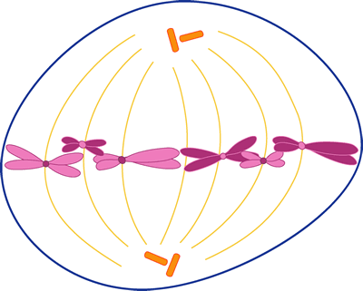 | 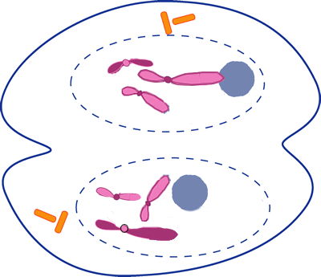 | 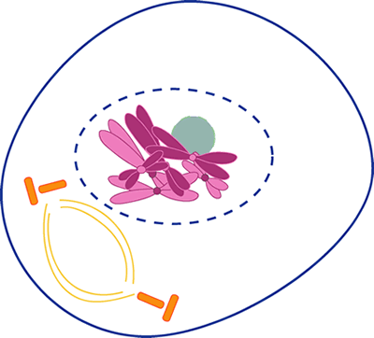

Another Mitosis Animation
Go to http://www.johnkyrk.com/mitosis.html . Draw a cell in each of the following phases.
Prophase | Metaphase | Telophase

Onion Root Tip
Online Activity at http://www.biology.arizona.edu/cell_bio/activities/cell_cycle/cell_cycle.html
Read the introduction, then click the “next” button.
You will have 36 cells to classify. When you’re finished, record your data in the chart below. Round to whole numbers.
 | Interphase | Prophase | Metaphase | Anaphase | Telophase | Total
Number of Cells
Percent of Cells (calculate: number of cells divided by total cells x 100)

Mitosis in Whitefish & Onion Roots
http://www.biologycorner.com/projects/mitosis.html . Click on the Whitefish embryo and the onion root tip.
For each organism, identify the stage of mitosis.
 | View 1 | View 2 | View 3 | View 4 | View 5
Whitefish
Onion

You Draw It!
Draw and Label each phase of Mitosis. Use pages 110-111 in your textbook

