Mendel & Genetics
Gregor Mendel: "______________________"
Some stuff on Mendel
- parents were farmers
- he became ordained as a priest
- studied science and mathematics at the University of Vienna
Blending Theory of Inheritance - offspring of ______ parents "blend" the traits of _____parents
Particulate Theory of Inheritance - traits are inherited as "_________________", offspring receive a "____________________" from each parent.
Evidence for Particulate Theory of Inheritance: A plant with purple flowers is crossed with another plant that has purple flowers. Some of the offspring have white flowers (wow!). Mendel set out to discover how this could happen.

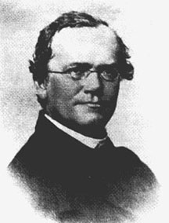
Mendel's Experiments
Mendel chose pea plants as his experimental subjects, mainly because they were easy to cross and showed a variety of contrasting traits (purple vs white flowers, tall vs short stems, round vs wrinkled seeds)
1. Mendel chose ___________________ of each plant/trait he studied (true breeding lines always produced offspring of the same type)
2. He crossed a true breeding plant with a plant of the opposite trait (purple x white). He called this the ___________________________________________________________. (In this case, he cross-pollinated the plants)
3. He recorded data on the offspring of this cross _________________________________
4. He self pollinated the F1 offspring
5. He recorded data on the offspring of the second generation, calling it the _________________________________________
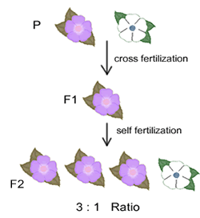
Analysis:
- The F1 generation always displayed one trait (he later called this the ____________________ trait)
- The F1 generation must have within it the trait from the original parents - the white trait
- The F2 generation displayed the hidden trait, 1/4 of the F2 generation had it (he later called this hidden trait the ________________________trait)
- Each individual has two "factors" that determine what external appearance the offspring will have. (We now call these factors genes or alleles)
Mendel established three principles (or Laws) from his research
1. The Principle of Dominance and Recessiveness - __________________________________________________________________________________________________________________________________________________________________________________________________________________
2. Principle of Segregation - __________________________________________________________________________________________________________________________________________________________________________________________________________________
3. Principle of Independent Assortment - _________________________________________________________
__________________________________________________________________________________________________________________________________________________________________________________________________________________
another way to look at this is, whether a flower is purple has nothing to do with the length of the plants stems - each trait is independently inherited

Modern Genetics
Mendel's factors are now called _____________________. For every trait a person have, two alleles determine how that trait is expressed.
We use letters to denote alleles, since every gene has two alleles, all genes can be represented by a pair of letters.
PP = purple, Pp = purple, pp = white
Homozogyous: when the alleles are the __________________, the individual is said to be homozygous, or true breeding. Letters designating a homozgyous individual could be capital or lowercase, as long as they are the same. Ex. AA, bb, EE, dd
Heterozygous: when the alleles are _____________________________, in this case the DOMINANT allele is expressed. Ex. Pp, Aa
Monohybrid cross = a cross involving _________________ of contrasting traits. Ex. Pp x Pp
Punnet Square: used to determine the ___________________________ of having a certain type of offspring given the alleles of the parents
Genotype: letters used to denote alleles (BB, Pp..etc)
Phenotype: what an organism looks like (brown, purple..)

How to Use Punnett Squares to Determine Probability
In pea plants, round seeds are dominant to wrinkled.
Assign genotypes:
RR = round
R r = round
r r = wrinkled
If two heterozygous plants are crossed (R r x R r ), set up the square as shown below.
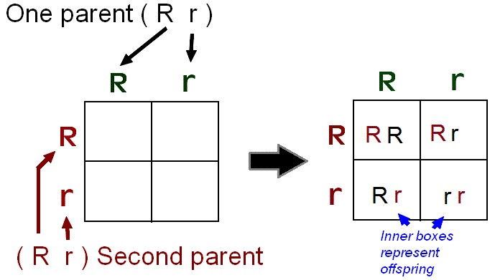

In this case _____% of the offspring will be wrinkled, and _____ % will be red.

