Mammals
Kingdom Animalia
---Phylum Chordata
------Subphylum Vertebrata
---------Class Mammalia

Characteristics of Mammals
1. Hair (some marine mammals have very little)
2. _____________________________
3. Endothermic
4. Mammary Glands
5. Placenta (most)
6. Diaphragm - muscle that aids breathing

Specialized Teeth
____________ - biting
_________ - stabbing, holding
____________ - crushing, grinding
Different types of mammals have different types of teeth - depending on their diet
Predators have large canines
Herbivores have large flat molars
Mammals have a __________________________ and a double loop circulatory system
Mammary Glands - used to nurse young, produce milk

Types of Mammals
Monotremes (egg layers), Marsupials (pouch), Placentals (uterus)

Order Monotremata
Egg laying mammals found only in Australia
Have reptilian characteristics (cloaca & egg laying)
Have mammalian features (hair, mammary gland)
Examples: Duck Billed Platypus and the Echidna (also called a Spiny Anteater)
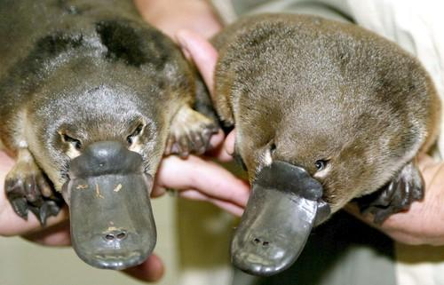

Order Marsupiala
Mammals bear their young in an immature state, babies develop in a pouch
Majority are found on Australia, opossums are found on other continents
Examples: Kangaroo, wallaby, tasmanian devil, koala (click to see pictures)
Kangaroo  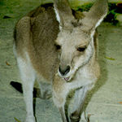 | Wombat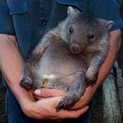 | Phalanger  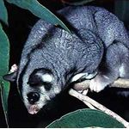 | Koala  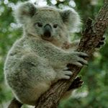 | Opossum  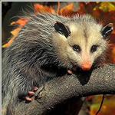

Placental Mammals
Placental Mammals have a gestation period (length of time in uterus)
Placenta- membrane that allows nutrients to pass thru from mom to baby
Domesticated animals have been kept and bred by people - cows, dogs, pigs, horses..etc
Placental Mammal Orders
Rodentia - teeth specialized for gnawing, incisors grow continuously. Ex. Mouse, rat, beaver
Chiroptera- flying mammals (membrane wing), use echolocation. Ex. bats
Insectivora - mainly eat insects, long noses. Ex. shrew & mole
Carnivora - flesh eating hunters, large canines. Ex. dog, cat, fox, lion, bear, raccoon
Pinnipedia - marine mammals that mate on land. Ex. Walrus, seal)
Primate - adapted for living in trees, intelligent, opposable thumbs. Ex. Chimpanzees, humans
Artiodactyla - type of ungulate (hoofed mammal), even toed, Ex, sheep, cow. Large rumen in stomach helps break down plant material.
Perissodactyla - type of ungulate, odd toed. Ex. horse, rhino. Plant material is digested in a cecum
Cetacea - marine mammals, use echolocation, have blowhole. Ex. whales & dolphins
Lagomorpha - one pair of long incisors, legs specialized for hopping. Ex. rabbits and hares
Sirenia - marine mammals that live in shallow water. Ex. Manatee & dugong
Proboscidea - named for their trunk, or proboscis, many have long tusks (incisor). Ex. elephants.
Xenarthran - Sloths, anteaters
Class Mammalia – Use the Mammal Presentation to complete the following Chart
Animal | Order | Description (special traits) | Members
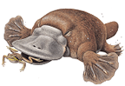
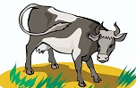
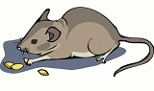
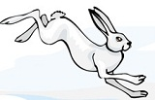
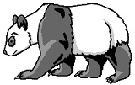
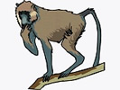
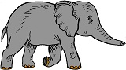

Animal | Order | Description (special traits) | Members
