Mammal Orders Practice
Choose the one in the group that does not belong with the others (circle).
1. cow | sheep | horse
2. cat | rat | dog
3. rabbit | kangaroo | koala
4. whale | manatee | dolphin
5. bear | sloth | armadilla
6. shrew | mole | mouse
7. horse | elephant | rhinoceros
8. hare | echidna | duck-billed platypus
9. human | bat | chimpanzee
10. zebra | rhinceros | elephant
Identify the order by description or picture
11. _____________________ Elongated nose forms a trunk, incisors form tusks
12. _____________________ Front limbs adapted for flying
13. _____________________ Long arms, opposable thumbs for grasping, intelligent
14. _____________________ Limbs modified into flippers, blowhole
15. _____________________ Incisors never stop growing, gnawing mammals
16. _____________________ Egg laying mammals
17. _____________________ Hoofed mammals, odd number of toes, has cecum
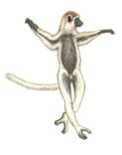  18. _________________ | 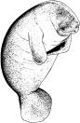  19. _______________ | 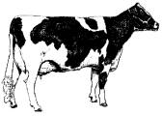  20. _________________

