I. Anatomy of a Fish (Coloring)
Most vertebrates have the same basic body plan when it comes to internal organs. Like other vertebrates, fish have an esophagus which leads ot the stomach where food is digested and passed to the intestine. Waste exits the fish at the anus. Some fish have a swim bladder (4) which can help with flotation. Fish have a two chambered heart (8) that is closely associated with the gills (7). The heart pumps blood over the gills where it becomes oxygenated and begins its path through the rest of the body, delivering that oxygen before returning the heart. This type of circulation is called single-loop circulation. Amphibians, mammals, and birds have double-loop circulation, where blood leaves the heart, goes to the lungs, and then returns to the heart before being pumped to the body.
7. Gills (red)
8. Heart (pink)
9. Pelvic Fin (green)
10. Liver (brown)
11. Stomach (green)
12. Intestine (dark blue)
13. Reproductive Organs (orange)
14. Anal Fin (pink)
1. Caudal Fin (blue)
2. Kidney (green)
3. Dorsal Fin (yellow)
4. Swim Bladder (blue)
5. Esophagus (yellow)
6. Operculum (brown)
--- Lateral Line System (black)
<< Scales (purple)
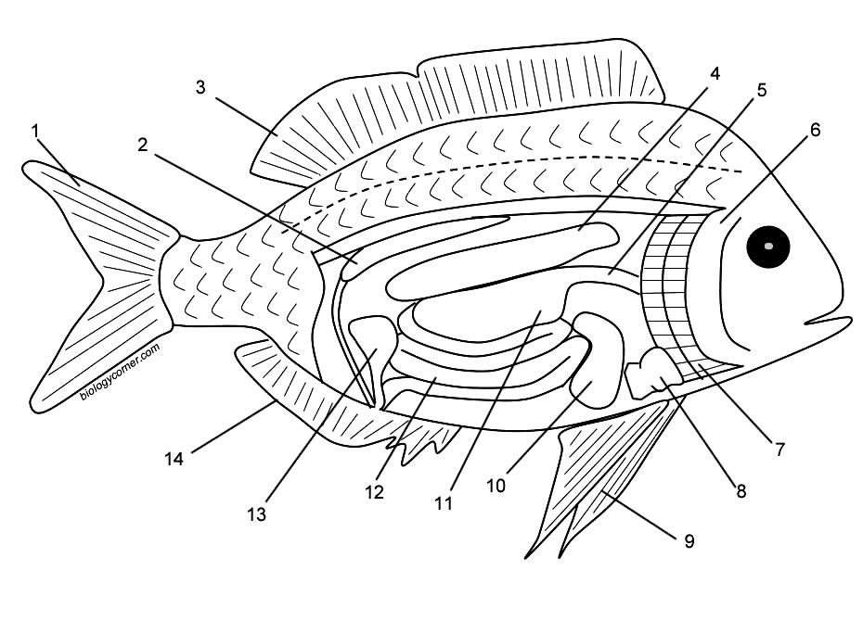
Using the description in the first paragraph, sketch a model of single loop circulation and double loop circulation.

II. Fish Scales Tell the Age of a Fish
Look at the image of the fish scale, like a tree, scales show rings that indicate periods of growth. Rings that are farther apart occur when the fish grows well and there is lots of food - in the summer season. Rings that are close together occur when the fish does not get much food and grows slowly. On the scale you can identify the summer growth and the winter growth. (There will be several rings in each).
The core represents the fish when it was first born, as a fry. The rings near the edge are the most recent periods of growth.
Color the summer growth periods green. | Color the winter growth periods blue. How old is this fish (in years)? ________
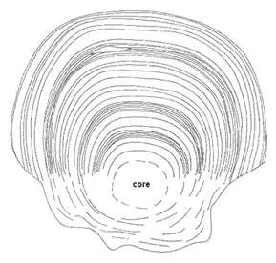

III. Fish Fins Are Used for Swimming
The fins of the fish are used for swimming but each one has a specific job. The dorsal fin is sometimes split into an anterior and posterior dorsal fin. Both are used to help the fish maintain its upright position in the water. The anal fin has the same function. Pectoral and pelvic fins are used for steering and the caudal fin is used to propel the fish forward. Fish swim in an side-to-side motion. Aquatic mammals swim with an up-and-down motion, which is consistent with their evolutionary relationship with land mammals. Label each of the fish's fins below and color.
Pelvic Fin (green)
Pectoral Fin (red)
Caudal Fin (blue)
Anal Fin (pink)
Dorsal Fin (yellow)
