Labeling the Map of Europe
Name: ____________________________________________ Hour: _____
Please label the following countries and physical features on your map of Europe.
Label the map neatly using a black or blue pen or a pencil.
Countries
Albania Slovakia
Andorra* Slovenia
Austria Spain
Belarus Sweden
Belgium Switzerland
Bosnia and Herzegovina Ukraine
Bulgaria United Kingdom
Croatia Vatican City*
Cyprus*
Czech Republic
Denmark
Estonia
Finland
France
Germany
Greece
Hungary
Iceland
Ireland
Italy
Latvia
Liechtenstein*
Lithuania
Luxembourg*
Macedonia
Moldova
Monaco*
Montenegro
Netherlands
Norway
Poland
Portugal
Romania
Serbia
Map Assignment Rubric

5 – Each location on the physical and political map is labeled correctly and neatly and is printed in black or blue ink or pencil. (NO RED PEN) Labels are in horizontal direction. All country names are capitalized. Countries are colored in- each of a different color (with colored pencils not markers or crayons). (A+)

4 – ¾ of the locations are labeled with capitals, spelled correctly, and are in the correct locations. Labels are not neatly readable by the instructor or are not all in horizontal direction. Countries are not colored. (C)

3 – Assignment is a little more than half complete. Labels are messy or unreadable by instructor or are not in horizontal direction. (F)

2 – Assignment is poorly attempted or locations are not labeled accurately. (F)

Grade: __________
Comments:
The countries with the * next to them are small and hard to find. I labeled Vatican City so you can see it. You can ask in class for help if you cannot find them.
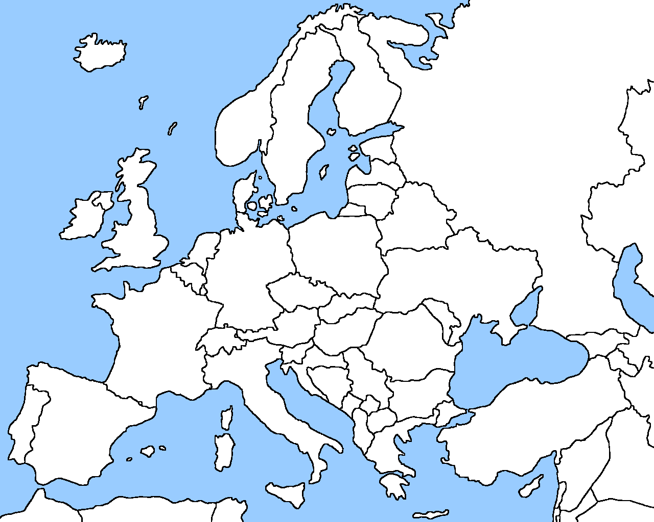
5.
4.
3.
2.
1.
1.
2.
3.
4.
5.
Vatican City

