Introduction to the Animal Kingdom
Most diverse kingdom in appearance
Each phylum has its own typical body plan (arrangement)
What is an Animal?
Animals are heterotrophic, ________________, and multicellular and lack cell walls.
95% = invertebrates (do not have backbone)
5% = vertebrates (have a backbone)
** Heterotroph: An organism that cannot manufacture its own food and instead obtains its food and energy by taking in organic substances, usually plant or animal matter.
Physiology = Study of the functions of organs
Anatomy = the structure of the organism/organs
Zoology = the study of ______________
What Animals do to Survive

There are 7 essential functions of animals:
1. Feeding:
Herbivore = __________
Carnivore = eats animals
Omnivore = eats plants and animals
Detritivore = feed on decaying organic material
Filter Feeders = aquatic animals that strain food from water
Parasite = _______________________________________ (symbiotic relationship)
2. Respiration:
Take in _______________ and give off ___________________
Lungs, gills, through skin, simple diffusion
3. Circulation:
Very small animals rely on diffusion
Larger animals have ______________
4. Excretion:
Primary waste product is ___________________
Liquid waste
5. Response:
Receptor cells = sound, light, external ________________
Nerve cells => nervous system
6. Movement:
Most animals are motile (can move)
Muscles usually work with a __________________
7. Reproduction:
Most reproduce sexually = _______________________________
Many invertebrates can also reproduce asexually = to increase their numbers rapidly

Trends in Animal Evolution
Body Symmetry -the body plan of an animal, how its parts are arranged
Asymmetry - ______________________ (corals, sponges)
Radial Symmetry - shaped like a ______________(starfish, hydra, jellyfish)
Bilateral Symmetry - has a right and left side (humans, insects, cats, etc)
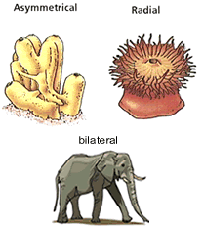
Cephalization - anterior concentration of sense organs, basically the organism has a head, usually with eyes, nose and other sense organs, plus a brain
Body sides: anterior: ___________, posterior:______________, dorsal:______________, ventral:____________
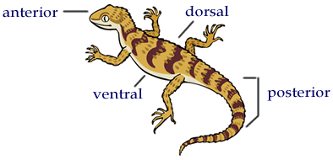
Segmentation - segments of the body become specialized for specific purposes

Trends in Animal Evolution
Early Development:
Zygote = _________________
Blastula = a hollow ball of cells
Blastopore = the blastula folds in creating this opening
Protostome = mouth is formed from blastopore
Deuterosome = anus if formed from blastopore
Anus = opening for solid waste removal from digestive tract
The cells of most animal embryos differentiate into three layers called germ layers
Endoderm = (innermost) develops into the lining of the digestive tract and respiratory tract
Mesoderm = (middle) muscle, circulatory, reproductive, and excretory systems
Ectoderm = (outermost) sense organs, nerves, outer layer of skin

Kingdom Animalia
1. Phylum Porifera (________________)
2. Phylum Cnidaria (sea anemones, jellyfish, coral, hydra)
3. Phylum Platyhelminthes (flatworms)
4. Phylum Nematoda (____________________)
5. Phylum Annelida (segmented worms, earthworms, leeches)
6. Phylum Mollusca (clam, squid, snails, slugs)
7. Phylum Arthropoda (crustaceans, insects, spiders)
8. Phylum Echinodermata (_______________)
9. Phylum Chordata (includes all vertebrates)

