BIRDS AND REPTILES
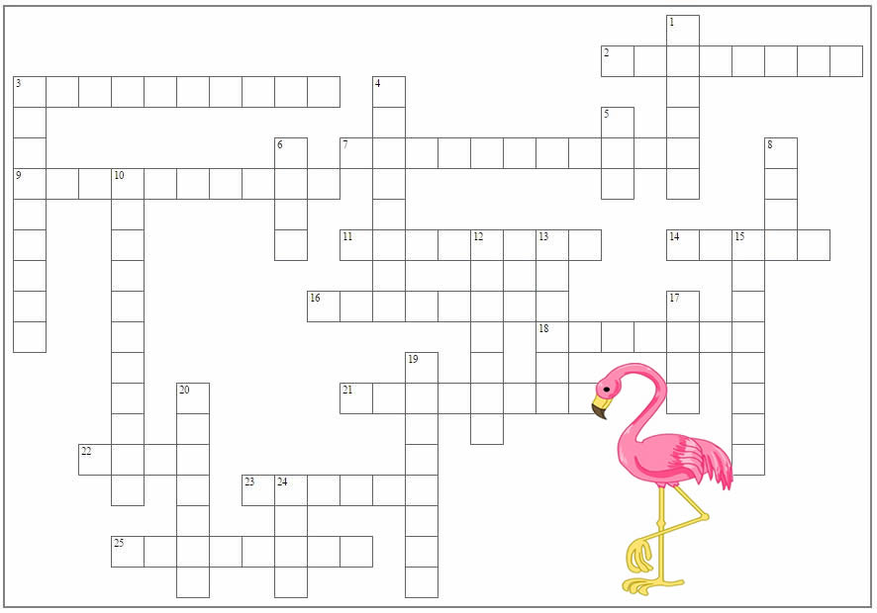
Across  - the phylum to which birds and reptiles belong  - type of venomous snake, named for its color  - small bird the feeds on the nectar of flowers  - part of the brain associated with balance  - top of the turtle's shell  - type of lizard found in car insurance commercials  - type of bird that is pink  - type of egg found in both birds and reptiles  - the state bird of Illinois  - type of venomous lizard, ___ monster  - type of constricting snake  - fused collarbone found in birds |  | Down  - largest lizard; ___ dragon  - reptile that takes care of its young  - the order to which snakes and lizards belong  - organ that detects heat in snakes  - type of bird that Daffy is  - a large bird of prey; red-tailed ____  - another name for warm-blooded  - bird that lives in the Antarctic, it swims but never flies  - eggs and waste exit here  - part of the brain involved in problem-solving  - number of chambers in a bird's heart  - bird grooming  - reptile known as a "living fossil" of New Zealand  - part of the egg that feeds the embryo

