Phylum Annelida

Main Characteristics
- segmented worms, true coelom (__________________________)
-Includes: earthworm, marine worms, leeches

- Annelida means "little rings"
- body divided into segments separated by septum (Septum=______________________)
- some have bristles called _________ on each segment
- have closed circulatory system
- have well-developed nervous system with brain & nerve cords
- _____________ reproduction, some are hermaphrodites
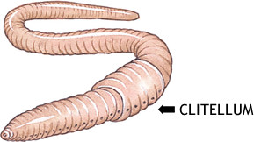

Groups of Annelids
1. Oligochaeta – Earthworm
- Streamlined bodies for moving through soil
- Few setae, allows for _____________- soil
- Live in soil or fresh water
- As earthworms pass food & soil through intestines, nutrients are absorbed and indigestible matter passes out through anus as castings
- Castings - enrich soil, earthworms aerate soil

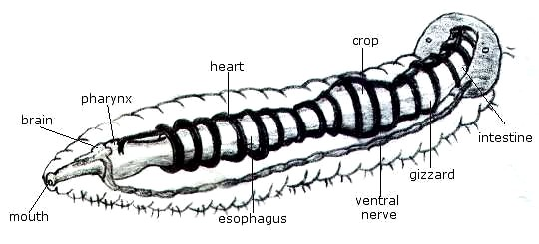
2. Class Hirudinea – Leeches
- external ___________ with suckers on each end
- suck blood & body fluids from host
- most live in moist tropical habitats
- medicinal uses (circulation, anti-clotting)

3. Class Polychaeta - Marine worms
-includes:sandworms, bloodworms, & relatives
-have paired paddlelike _________________ with setae
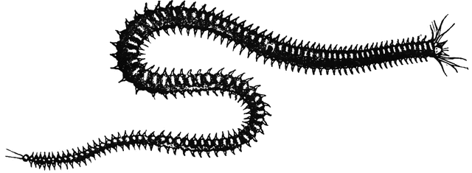

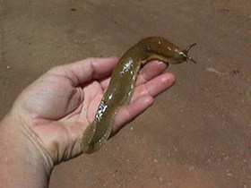
Phylum Mollusca – means “soft”
What is a Mollusk??
______________________________________________
Ex. ______________________________
Both have a true coelom (body cavity)
Similar larval stage - trochophore
Bilateral Symmetry
Organ systems
Characteristics of Mollusks – Body Plan
· ___________________________ (organs)
· Mantle (outer body layer)
· Foot (muscle, movement)
· Shell in most
· Radula - tongue-like structure, sharp
· Gills for respiration
· Most have separate sexes
Types of Mollusks
· Gastropods - snails, slugs, nudibranchs ("stomach foot")
· Bivalves - clams, oysters ("two doors")
· Cephalopods - nautilus, cuttlefish, squid, octopus ("head foot")
1. Gastropod
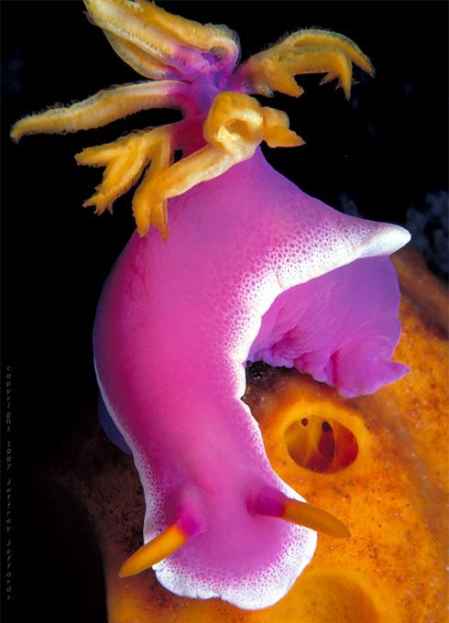
- snails, slugs and nudibranchs (sea slugs)
- _______________ or _______________
- Move by a muscular foot
- Some are poisonous, beware bright colours
2. Bivalves
- have _____ shells
- ex. clams, scallops

3. Cephalopods
- octopid, squids, cuttlefish and nautilus
- ___________, head attached to foot
- Foot is divided into tentacles with sucking disks
- Small internal shells or no shell at all
Nautilus is only cephalopod with shell
- Squid have a modified shell called a pen
- Well-developed eyes
- most complex of the mollusks

Squid vs. Octopus
Both squid and octopus are aquatic animals with eight long arms. In addition to their eight arms, squid also have two long tentacles. They also have two fins on their head, unlike the octopus. Whereas an octopus has no hard shell or bone in its body, squid have a stiff backbone-like structure called a pen.
A squid is any of a variety of cephalopod with a long, soft, thin body and 10 arms (eight shorter arms and two long tentacles) and two fins on its head. Squid vary in size from very small to over 65 feet in length. They prey upon fish and crustaceans. Some squid have the ability to emit an inky cloud as a defense mechanism. Their tentacles may have hooks, suckers, or sucker rings. They live in the open ocean.
An octopus is any of a variety of cephalopod with a round head, soft body and 8 strong tentacles, each with two rows of suckers. Octopi range from 1 cm to over 5 meters in length. They live on the sea floor and obtain food by piercing it and injecting it with venom.

