Animal Symmetry and Phyla
 | Animal | Phylum | Symmetry
 | Snail
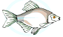 | Fish
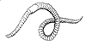 | Earthworm
 | Anemone
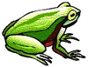 | Frog
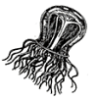 | Jellyfish
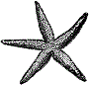 | Starfish
 | Alligator
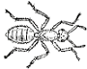 | Ant
 | Elephant
 | Coral
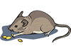 | Mouse
Add Your Own Animals below (3)
Publisher: Biologycorner.com; follow on Google+

