Animal Phylum Matching
Instructions: Draw a line from the Phylum to the organism that matches it. Draw another line from the organism to its description.
Cnidaria | 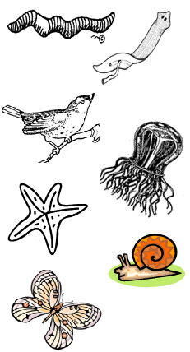 | These marine animals have plates with spines
Chordata |  | Three body parts, jointed legs, tough exoskeleton
Mollusca |  | Soft, thin, flat bodies
Arthropoda |  | Soft bodied animals usually have a shell
Echinoderm |  | Long animals divided into segments
Annelida |  | Jelly-like animals that have a bell or umbrella shape
Platyhelminthes |  | Animals that have a notochord that supports the body (or backbone)
Quick Match: For each animal or description listed, name the phylum it is associated with:
1. Cow _______________________________________________________
2. Lobster ____________________________________________________
3. Leech _____________________________________________________
4. Tapeworm _________________________________________________
5. Sea anemone ______________________________________________
6. Sea urchin _________________________________________________
7. Octopus ___________________________________________________
8. Bell or umbrella shaped bodies __________________________________
9. Most have a backbone _________________________________________
10. Jointed legs ________________________________________________
11. Thin, flat bodies _____________________________________________
12. Soft bodies, some have shells __________________________________
13. Spiney plates ______________________________________________
14. Exoskeleton ________________________________________________
15. Segmented, long bodies _______________________________________

