Google slides - Meiosis Notes
https://docs.google.com/presentation/d/19GDM6VHuQlF8XAqDNLtee-AZciFv0CH-pXMeRhSqZ78/present?slide=id.i0
- Every cell has a __________________ and every nucleus has ____________________________.
- The number of chromosomes depends on the ________________. Example: Humans have ____________, chickens have ____________.
- __________________ are located on chromosomes. Genes control the _________________ of the individual. Genotype determines ______________________.
- Chromosomes come in matching sets called ______________________ pairs. Cells in your body have a complete set (46) and are called_______________. Sex cells (sperm and egg) have only half (23) and are called __________________.
- When gametes (sperm and egg) combine, the __________________ (offspring) gets half from mom (23) and half from dad (23). Zygotes are ____________________(46).
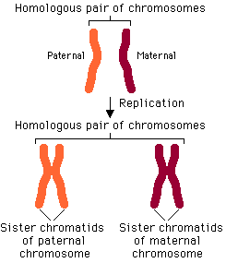
- Review questions:
- Matching sets of chromosomes are called __________________ pairs
- Egg and sperm combine to make a ___________________
- Egg and sperm are both known as __________________
- A cell that has only half a set of chromosomes is said to be _________________
- Genes are located on _____________________
- The process of creating a _________________ (sex cell) is called _____________________. It is similar to mitosis but will produce __________ daughter cells that are all ____________________.
- ________________________ makes egg (ovum).
- ________________________ makes sperm.
- Prophase I:
  - Homologous pairs form
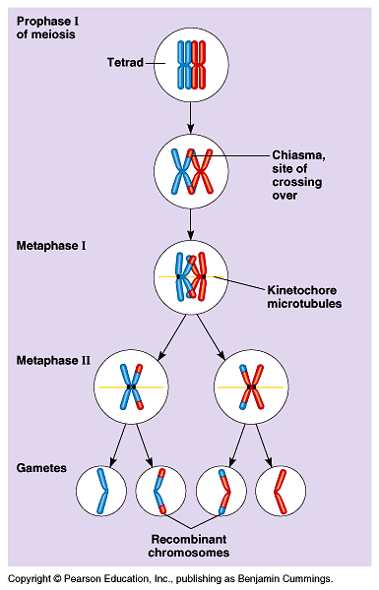
  - Chromosomes trade genes – Crossing over
  - ___________________ increases the number of gene combinations
- The purpose of Meiosis is to:
a)
b)
c)
d)
- Meiosis only occurs in what type of cells?
- Zygotes
- Skin cells
- Gametes
- Mitochondria

